Falmouth & Penryn Community Network Area
Covid19 Community Support Volunteers

Date: 19th June 2020

Dear St Gluvias parish volunteers,

Cornwall Councillors of the Falmouth & Penryn Community Network Area would like to take this opportunity to thank you for your continued invaluable support to vulnerable members of the community during the current crisis.

During the early days of lockdown, you quickly mobilised volunteers within the parish to provide much needed support and help to those members of the community who may not have considered themselves to be vulnerable but have had to self isolate.

Volunteers in this Community Network area (9 parishes in total) along with support from Volunteer Cornwall, embraced this difficult situation and worked out the most suitable approach to support those neighbours/friends/members of the community who needed help.

As we have been celebrating Volunteer Week recently, messages have been given from all sectors of Cornwall https://www.youtube.com/watch?v=ZP5zNWPcykk&feature=youtu.be , however on behalf of the Cornwall Councillors in this Community Network Area we also wanted to say a personal thank you to all of you as you have given so much to so many people.

You have mobilised and formed some incredible groups that have gone above and beyond to ensure that people have the food, medicines and friendly face/voice they need.

As this crisis continues it may be that the focus of work changes and I would encourage you to continue to contact your Councillor or Esther Richmond, Community Link Officer at Cornwall Council if you identify any additional support required. Please also note that each of the Cornwall Councillors still have funding available if there is a continued need in your parish.

Once again, thank you very much.

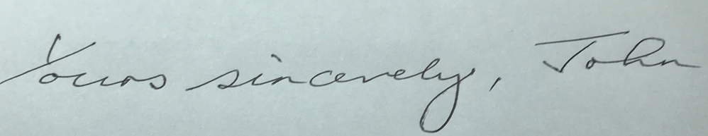

Councillor John Bastin - Chair

For and on behalf of the Falmouth & Penryn Community Network Cornwall Councillors:

Cllr John Bastin – Constantine, Mawnan and Budock
Cllr Geoffrey Evans – Falmouth Arwenack
Cllr Alan Jewell – Falmouth Boslowick
Cllr Jayne Kirkham Falmouth Smithick
Cllr John Symons – Penryn East and Mylor
Cllr Mary May – Penryn West
Cllr David Saunby – Falmouth Trescobeas
Cllr Matthew MCarthy – Falmouth Penwerris
Cllr Peter Williams – Mabe, Perranarworthal and St Gluvias

